**DATABASE MANAGEMENT SYSTEMS LAB**

NAME-LEPAKSHI JAGMOHAN

SAPID-500119039

RNO-R2142230040

BATCH-2

**EXPERIMENT-14**

**To understand the concepts of function and procedure in PL/SQL.**

1. Implement the above experiments of PL/SQL using functions and procedures.

FUNCTION-

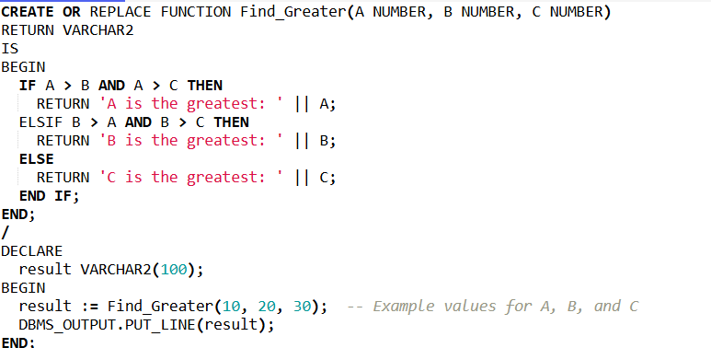

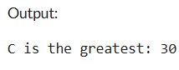

PROCEDURE-

